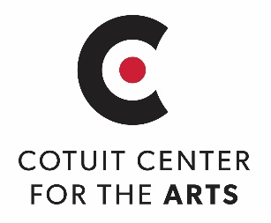 |  | BLUES: An Open Juried Exhibit  March 21 – April 25, 2020

Artist's Name:
Email:
Phone:
Mailing Address:

I prefer to be contacted via: Phone Email

Title of Work:
Medium:

Artist agrees to offer the work for sale, Sale Price: $______________
Artist requests work not be offered for sale, Insurance Value $________________
Artist agrees that Cotuit Center for the Arts will receive 40% of the sale price and will pay the artist 60% of the sale price. Fee to be paid within 2 weeks after conclusion of exhibit. A completed IRS Form W-9 will be required for payment to be processed for works priced at or above $600.00
Artist agrees that accepted work will remain on display at CCftA for the FULL duration of the exhibit.
The pick-up date for exhibited work is: April 26th, 10am – 4pm.
Cotuit Center for the Arts agrees that by taking possession of the above described artwork we will take reasonable care to return it in the same condition as when received. CCftA will not be / is not responsible for any materials, or lost, stolen, or damaged artwork while being exhibited or in the care, custody, and control of CCftA. This contract is terminated upon return of the described artwork to the artist.
Artist's Signature: | Date:

_ _ _ _ _ _ _ _ _ _ _ _ _ _ _ _ _ _ _ _ _ _ _ _ _ _ _ _ _ _ _ _ _ _ _ _ _ _ _ _ _ _ _ _ _ _ _ _ _ _ _ _ _ _ _ _ _ _ _ _ _ __ _ _ _ _ _

Attach this portion to the back of work:

Artist Name:
Title of Work:

SAVE FOR YOUR RECORDS
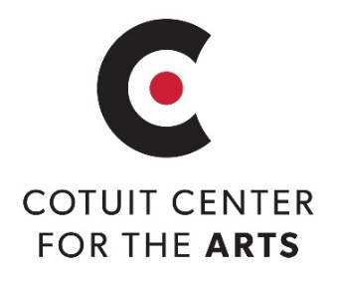
BLUES: An Open Juried Exhibit
March 21 – April 25, 2020
OPENING RECEPTION: MARCH 21, 5:00 -7:00 PM

Names of artists whose work has been selected for the exhibition will be listed on www.artsonthecape.org by Wednesday, March 18th
Artwork NOT selected for display must be retrieved by 4pm Friday, March 20, 2020

Pick up date for exhibited artwork: MONDAY APRIL 26, 2020 10am – 4pm
A 60% commission for sold artwork will be paid within 2 weeks after the conclusion of the exhibit.
A completed IRS Form W-9 will be required for payment to be processed for works priced at or above $600.00

Cotuit Center for the Arts 4404 Falmouth Road, Cotuit MA 02635 - 508-428-0669
Michelle Law Gallery Manager/Visual Specialist michelle@cotuitcenterforthearts.org

