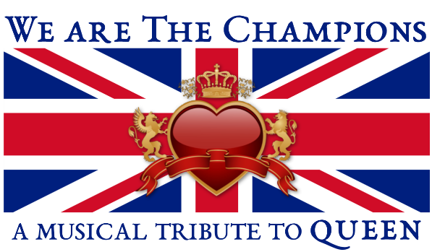

Featured Singers:

Emily Wade Adams

Born & raised on Cape Cod, Emily attended Wake Forest University as a Presidential Scholar for Voice before moving to San Francisco, where she performed with Ray of Light Theatre in The Who's Tommy (Mrs. Walker), Jerry Springer: The Opera (Shawntel), and Grease (Marty). She also sang with the San Francisco Symphony and fronted a retro R&B band called the Cosmo Alleycats, with whom she performed at Yoshi's, the Boom Boom Room, and the Fillmore Street Jazz Festival. In 2013, Emily returned to the East Coast, and has since appeared at Broadway's Feinstein's/54 Below, the Cotuit Center for the Arts, Wellfleet Preservation Hall, and the Spire Center for the Performing Arts with her cabaret tribute to Amy Winehouse, Love is Blind. Her NYC-based jazz quintet, The Café Society, brings its Nancy Wilson Tribute to Cape Cod & Plymouth August 28-30. Learn more at emilywadeadams.com

John Connelly

John is a singer and multi-instrumentalist who’s been playing all of his life. John has lived all over the country playing with numerous artists from Nashville to Los Angeles and has toured frequently in between. He grew up on the Cape and has a huge love of theatre. Getting to do a show like this is really exciting. Among his many talents, John is also a songwriter and is currently writing his own musical.
Allie Jason

Allie is a powerful and versatile performer with a deep passion for music and people. Allie has an authentic and captivating performance style, reminiscent of music legends Janice Joplin and Grace Slick. A native of Cape Cod, Allie grew up in local theater and the music scene, performing with the Harwich Junior Theater, Nauset High School and at the Annual March of Dimes telethon on Cape Cod. Finding her love for singing and songwriting at the age of 8, Allie began taking guitar lessons and writing songs. Allie has won songwriting contests on Cape Cod as well as participating in the Nashville Songwriters Association songwriter contests, and regarded as a “Baby Pink”. She has performed in Boston and New York and has been setting her sights on the Nashville music scene. She performs all over the Cape with her self-named band, “The Walrus and the Carpenter”. Her EP “Wonderland” can be found on ITunes, Apple Music, Amazon and other digital outlets. Allie has grown up around music and mentored by some of music’s finest musicians. A huge fan of Queen and inspired by Freddie Mercury, Allie steps on the Cotuit stage ready to rock you!

