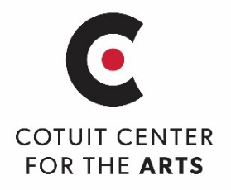 |  |  |  |  | Winter Art 2021: WE ARE CAPE COD  Portraits of Cape Codders by Cape Codders  $10 SUBMISSION FEE PAID ______of ______ submissions
 | Artist's Name:
 | Email:
 | Phone:
 | Address:

I prefer to be contacted via: Phone Email

Title of Work:
Medium:
Cape Cod Town of Portrait Subject’s Residence:
__________________________________________________________________________________________________
Artist agrees to offer the work for sale, Sale Price: $______________
Artist requests work not be offered for sale, Insurance Value $________________
NEW! Artist will provide a high-resolution image of their work for use in the online gallery. Send to michelle@cotuitcenterforthearts.org by Friday, February 5th, 2021
Artist agrees that Cotuit Center for the Arts will receive 40% of the sale price and will pay the artist 60% of the sale price. Fee to be paid within 2 weeks after conclusion of exhibit. A completed IRS Form W-9 will be required for payment to be processed for works priced at or above $600.00
Artist agrees that accepted work will remain on display at CCftA for the FULL duration of the exhibit.
The pick-up date for exhibited work is, March 22nd, 10am – 4pm.
Cotuit Center for the Arts agrees that by taking possession of the above described artwork we will take reasonable care to return it in the same condition as when received. CCftA will not be / is not responsible for any materials, or lost, stolen, or damaged artwork while being exhibited or in the care, custody, and control of CCftA. This contract is terminated upon return of the described artwork to the artist.
Artist's Signature: | Date:

_ _ _ _ _ _ _ _ _ _ _ _ _ _ _ _ _ _ _ _ _ _ _ _ _ _ _ _ _ _ _ _ _ _ _ _ _ _ _ _ _ _ _ _ _ _ _ _ _ _ _ _ _ _ _ _ _ _ _ _ _ __ _ _ _ _ _

CUT & ATTACH THIS PORTION TO THE BACK OF WORK:

Artist Name: __________________________________________________________________________________________________________________
Title of Work:

SAVE FOR YOUR RECORDS
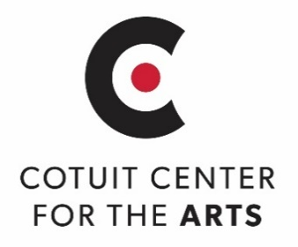
WINTER ART 2021: We are Cape Cod
Portraits of Cape Codders by Cape Codders
February 6 – March 20, 2021

Pick up date for exhibited artwork: MARCH 22, 10am – 4pm
A 60% commission for sold artwork will be paid within 2 weeks after the conclusion of the exhibit.
A completed IRS Form W-9 will be required for payment to be processed for works priced at or above $600.00

Cotuit Center for the Arts 4404 Falmouth Road, Cotuit MA 02635 - 508-428-0669
Questions? Contact: Michelle Law Exhibitions Specialist michelle@cotuitcenterforthearts.org

